**Chapter 6 - Animal Reproduction**

**All Lectures Uploaded on YouTube:**

[**https://tinyurl.com/fkm10-biology**](https://tinyurl.com/fkm10-biology)

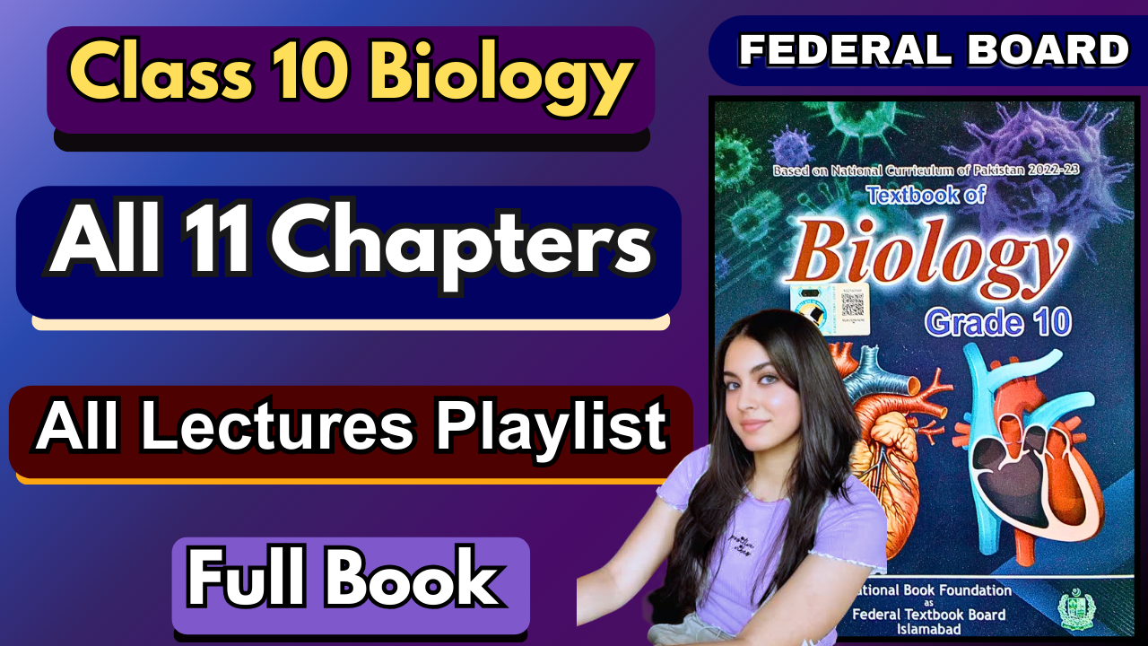

**MCQs:**

1. B
2. B
3. B
4. B
5. B
6. C
7. C
8. B
9. C
10. B
11. B
12. A
13. B
14. C
15. D

**Short Answers:**

1. **What is the primary purpose of reproduction in living organisms?**

The main purpose of reproduction is to ensure the survival and continuity of a species. It allows living organisms to pass on their genetic information to the next generation.

1. **What are the two main types of reproduction?** Reproduction occurs in two main forms: **asexual** and **sexual**. In asexual reproduction, a single parent produces offspring genetically identical to itself, ensuring rapid population growth. In sexual reproduction, gametes from two parents fuse, producing genetically varied offspring that enhances adaptability.
2. **At what stage of human development does the reproductive system become functional?** The reproductive system becomes functional at **puberty**, a stage usually beginning in adolescence. During this period, hormonal changes stimulate the maturation of reproductive organs. Puberty also leads to gamete formation and the development of secondary sexual characteristics.
3. **Which hormone is primarily responsible for the development of male secondary sexual characteristics?  
   Testosterone**, produced by the Leydig cells of the testes, is responsible for male secondary sexual traits. It causes features such as deepening of the voice, growth of facial and body hair, and increased muscle mass. It also plays a role in sperm production and sex drive.
4. **What role do Sertoli cells play in the male reproductive system?**Sertoli cells, located in the seminiferous tubules, provide nourishment and support to developing sperm cells. They create a protective environment for spermatogenesis and regulate the process through hormonal signals. They also form the blood-testis barrier to safeguard germ cells.
5. **Which hormone is essential for spermatogenesis and acts on Sertoli cells?  
   Follicle-stimulating hormone (FSH)** is crucial for spermatogenesis in males. It directly acts on Sertoli cells, stimulating them to support and nourish sperm cells during their development. Along with testosterone, FSH ensures continuous production of healthy sperm.
6. **Which hormone is primarily responsible for the development of female secondary sexual characteristics?  
   Estrogen** is the main hormone responsible for female secondary sexual traits. It stimulates breast development, widening of hips, and fat deposition in specific areas of the body. Estrogen also regulates the menstrual cycle and prepares the uterus for pregnancy.
7. **What triggers ovulation in the female reproductive cycle?** Ovulation is triggered by a sudden **surge of luteinizing hormone (LH)** released by the pituitary gland. The LH surge occurs due to high levels of estrogen from the mature follicle. This leads to the rupture of the follicle and release of an ovum from the ovary.
8. **Where is progesterone produced in the female reproductive system after ovulation?**After ovulation, progesterone is produced by the **corpus luteum**, which develops from the ruptured follicle in the ovary. Progesterone plays an essential role in maintaining the uterine lining, preparing it for implantation of a fertilized egg.
9. **What is the term for the process of sperm cell production?** The process of sperm cell production is called **spermatogenesis**. It occurs in the seminiferous tubules of the testes and involves several stages of cell division and differentiation. Spermatogenesis produces mature spermatozoa capable of fertilising an ovum.
10. **In which part of the male reproductive system does spermatogenesis occur?** Spermatogenesis takes place in the **seminiferous tubules** within the testes. These tubules contain germ cells and Sertoli cells that regulate and nourish the developing sperm. The process continues throughout a male’s reproductive life after puberty.
11. **Where does fertilisation typically occur in the female reproductive system?** Fertilization in humans typically occurs in the **fallopian tubes (oviducts)**. This is where the sperm meets the ovum after ovulation. The fertilized zygote then travels to the uterus for implantation and further development.
12. **What is the genetic outcome of offspring produced through asexual reproduction?** Offspring produced by asexual reproduction are **genetically identical clones** of the parent. Since no gametes or genetic mixing are involved, variation is absent. This ensures rapid population increase but reduces adaptability to environmental changes.
13. **What role does the scrotum play in the reproductive system of a male rabbit?** The scrotum houses the testes outside the body, maintaining a temperature slightly lower than body temperature. This is crucial for sperm production, as high internal body heat can damage sperm. It also protects the testes from mechanical injury.
14. **Which part of the female reproductive system in rabbits is the typical site for fertilisation?** In rabbits, fertilisation usually occurs in the **oviduct (fallopian tube)**. This is where sperm encounter the ovum after it has been released from the ovary. The fertilised egg then travels to the uterus for implantation and development.

**Extensive Answer Questions**

### **1. Explain the role of hormones in male sexual development, detailing the specific functions of testosterone and follicle-stimulating hormone (FSH). How do these hormones interact to regulate spermatogenesis?**

**Testosterone**, produced by Leydig cells, is the key hormone for the development of male secondary sexual characteristics such as voice deepening, body hair growth, and muscle mass. It also plays a crucial role in stimulating **spermatogenesis**. Follicle-stimulating hormone (**FSH**), secreted by the pituitary gland, acts on Sertoli cells to nourish and support developing sperm cells. Together, FSH and testosterone maintain sperm production by coordinating the environment in the seminiferous tubules. Their interaction ensures continuous male fertility.

### **2. Compare and contrast the processes of spermatogenesis and oogenesis.**

Spermatogenesis is the continuous process of sperm production in the seminiferous tubules, producing millions of motile sperm daily from puberty throughout life. Oogenesis, however, occurs in the ovaries and is a cyclical process, beginning before birth but maturing one egg per menstrual cycle. While spermatogenesis produces four functional gametes from each germ cell, oogenesis produces only one ovum and three polar bodies. Spermatogenesis is abundant and lifelong, whereas oogenesis is limited and ends at menopause.

### **3. Discuss the process of fertilization in humans, explaining the significance of internal versus external fertilization. How does fertilization restore the diploid chromosome number?**

Fertilization in humans is an internal process, occurring in the fallopian tubes when sperm fuses with the ovum. Internal fertilization provides protection to gametes and ensures a higher chance of successful union compared to external fertilization, where gametes are released outside the body. During fertilization, the haploid sperm nucleus (23 chromosomes) fuses with the haploid ovum nucleus (23 chromosomes), restoring the diploid number (46). This zygote then undergoes cell division to initiate embryonic development.

### **4. Outline the key steps involved in sexual reproduction, using the rabbit as an example to describe the male and female reproductive systems, fertilisation, and subsequent development.**

In rabbits, the male reproductive system includes testes, vas deferens, and penis, which produce and deliver sperm, while the female system consists of ovaries, oviducts, uterus, and vagina, which produce eggs and provide a site for fertilisation. Fertilisation occurs internally in the oviducts where sperm meets the ovum. The zygote develops into an embryo, which implants in the uterus for further growth. Sexual reproduction in rabbits ensures genetic variation and adaptation through mixing of parental traits.

### **5. Describe the mechanisms of asexual reproduction in animals. Provide examples of binary fission, budding, fragmentation, regeneration, and parthenogenesis, explaining how each process contributes to the reproduction of organisms.**

Asexual reproduction produces offspring from a single parent without gametes, resulting in genetically identical clones. **Binary fission**, as in amoeba, involves splitting into two equal cells. **Budding**, seen in hydra, forms a new organism from an outgrowth. **Fragmentation**, like in planaria, produces new individuals from body parts. **Regeneration**, as in starfish, restores lost parts into whole organisms. **Parthenogenesis**, found in some reptiles and insects, allows egg development without fertilization. These methods ensure rapid multiplication.

### **6. Explain the process of sex determination in humans. What is the chromosomal basis for determining the sex of an individual, and how do sperm and eggs contribute to this process? Discuss the role of the SRY gene in the development of male sex organs.**

In humans, sex determination is based on the chromosomal combination inherited from the parents. Eggs always carry an **X chromosome**, while sperm can carry either **X or Y**. Fertilisation with an X sperm produces a female (XX), while a Y sperm produces a male (XY). The Y chromosome contains the **SRY gene**, which activates the development of testes and male reproductive organs. Absence of the SRY gene leads to female differentiation.

### **7. Discuss the differences between viviparous, oviparous, and ovoviviparous animals. Provide examples of each and explain how their reproductive strategies are adapted to their environments.**

**Viviparous** animals, such as humans and mammals, give birth to live young after internal development, offering maximum protection. Oviparous animals, like birds and reptiles, lay eggs outside the body, relying on protective shells and parental care. Ovoviviparous animals, such as some sharks and snakes, retain eggs inside the body until hatching, giving young both protection and independence. These strategies reflect adaptations to habitat, ensuring higher survival rates under different environmental pressures.

### **8. Explain the significance of gametogenesis in sexual reproduction. How does meiosis contribute to genetic variation in offspring, and why is this variation important for the survival and evolution of species?**

Gametogenesis is the process by which specialised sex cells (sperm and eggs) are formed through meiosis. Meiosis reduces the chromosome number to a haploid and introduces variation through crossing over and independent assortment. This genetic diversity ensures that no two offspring are identical, increasing adaptability to changing environments. Variation is vital for natural selection, survival against diseases, and the long-term evolution of species. Without it, populations would struggle to adapt and survive.

